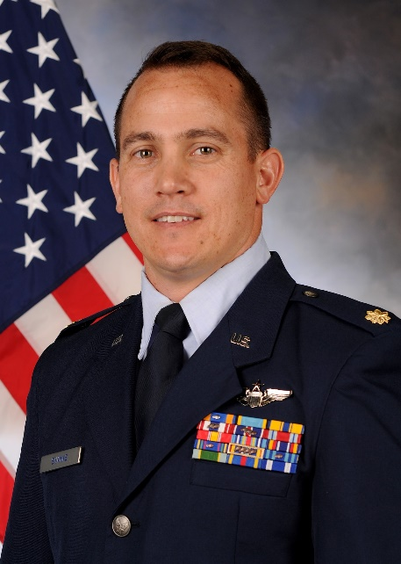
MAJOR PATRICK J. SHANKS

Major Patrick J. Shanks is currently Director of Staff at the 306th OSS and a T-53 (Cirrus SR-20) Instructor Pilot in the 306th Flying Training Group at the United States Air Force Academy, Colorado Springs, Colorado.

Prior to his current position, Maj Shanks was a Formal Training Unit Instructor Pilot for KC-135 aircrew at the 54th Air Refueling Squadron, Altus AFB, Oklahoma. There he served as the Chief of Standardization and Evaluations overseeing more than 800 checkrides per year.

While assigned to the 909th Air Refueling Squadron at Kadena AB, Japan, Major Shanks served as the Chief of Squadron Tactics and Flight Commander of 18 Component Maintenance Squadron.

At Fairchild AFB, Washington, he served as the 92nd ARS Executive Officer and deployed 5 times in support of Operation ENDURING FREEDOM in the 22nd Expeditionary Air Refueling Squadron, Manas AB, Kyrgystan. He also deployed to Moron AB, Spain in support of Operations ODYSSEY DAWN and UNIFIED PROTECTOR.

EDUCATION
2007 BS Accounting, Colorado State University, CO
2007 Air and Space Basic Course, Maxwell AFB, AL
2009 Undergraduate Pilot Training, Laughlin AFB, TX
2011 Squadron Officer School, by correspondence
2013 Squadron Officer School, Maxwell AFB, AL
2014 Combat Aircrew Tactics Studies, St Joseph, MO
2015 Master of Business Administration, Liberty University, VA
2020 Air Command and Staff College, by correspondence

ASSIGNMENTS
- Sep 2007 – Apr 2008, Dyess AFB, TX
- Apr 2008 – Jun 2010, Laughlin AFB, TX
- Jun 2010 – Apr 2014, Fairchild AFB, WA
- Apr 2014 – Apr 2017, Kadena AB, Japan
- April 2017 – Sep 2019, Altus AFB, OK
- Sep 2019 – present, USAFA, CO

MAJOR AWARDS AND DECORATIONS
Air Medal, with five oak leaf clusters
Aerial Achievement Medal
Meritorious Service Medal
Air Force Commendation Medal

EFFECTIVE DATES OF PROMOTION
Second Lieutenant 11 May 2007
First Lieutenant 1 Jun 2009
Captain 1 Jun 2011
Major 1 Jun 2017
(Current as of May 2023)

